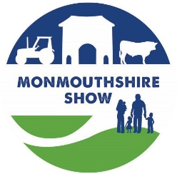
MONMOUTHSHIRE SHOW – Livestock Entry Form 2025
Entries Close on Monday 4th August 2025
ALL EXHIBITORS WILL RECEIVE A PACK VIA EMAIL WITH INFORMATION REQUIRED
BEFORE THE SHOW DAY, WITH PASSES/TICKETS.

Exhibitors Name:
Address:
Email address: Mobile number:
CLASS NUMBER | BREED | EARTAG NUMBER  (Cattle only) | ANIMALS - DATE / YEAR OF BIRTH | Young Handlers  Name / Date of Birth | Entry Fee  £5  Member free
Sheep exhibitors: No of pens required ……………..
I have read and understood the Monmouthshire Show Livestock Rules.

Please Sign here ........……………………………………….…..…. Dated ……………………….….

Please send entries to livestock@monmouthshow.co.uk / Mrs I Coates, St. Dials Farm, Monmouth, NP25 4HY.

