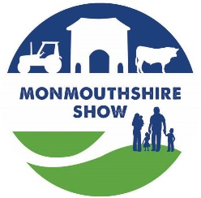
MONMOUTHSHIRE SHOW – Livestock Entry Form 2026
Entries Close on Monday 3rd August 2026
ALL EXHIBITORS WILL RECEIVE A PACK VIA EMAIL WITH INFORMATION REQUIRED
BEFORE THE SHOW DAY, WITH PASSES/TICKETS.
Exhibitors Name:
Address:
Email address: Mobile number:
CLASS NUMBER | BREED OF CATTLE / SHEEP  Pygmy Goat – Sire & Dam  Name & Reg No | EARTAG NUMBER  for Cattle and Goats  (Plus Goats Reg No) | ANIMALS - DATE / YEAR OF BIRTH | Young Handlers  Name / Date of Birth | Entry Fee  £5  Members Free
Sheep & Goat exhibitors: No of pens required …………….. MV accredited – YES / NO (Please attach the current certificate with entry)
I have read and understood the Monmouthshire Show Livestock Rules.
Please send entry form to livestock@monmouthshow.co.uk / Mrs I Coates, St. Dials Farm, Monmouth, NP25 4HY
Please pay for your entries using BACS details – Monmouthshire Show Society Ltd Sort Code 51-61-02 Account No 04219260
Please use the reference of LS followed by your exhibitor surname. Eg LSJones
Please Sign here ........……………………………………….…..…. Dated ……………………….….

